**Step1:** Open Visual Studio 2015 and Create a MVC 5 web application with name “**ManageAzureVMApp**”

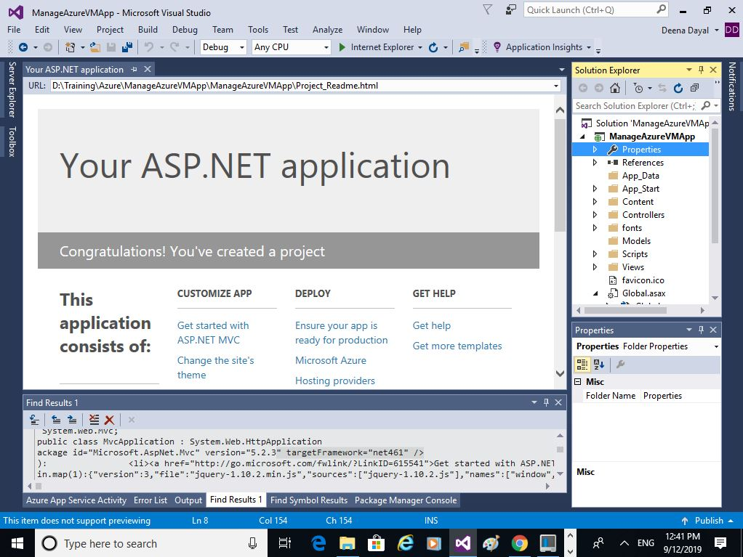

**Step2:** Check whether Angular CLI and dependencies are installed and verify the version. We use Angular 8.

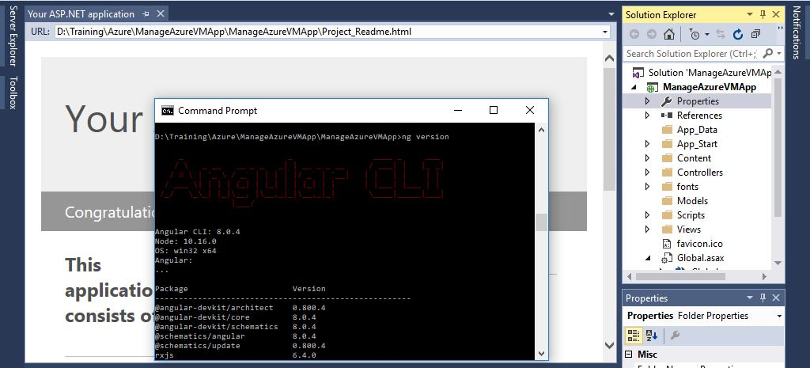

**Step3:** Create a new angular app with name “AzureVMMgmtApp” inside the web application project folder created at **Step1** using the following command.

**ng new AzureVMMgmtApp --minimal**

**Step4:** Verify the new angular application using **ng build** and **ng serve** commands and browse the application using “**http//localhost:4200**”

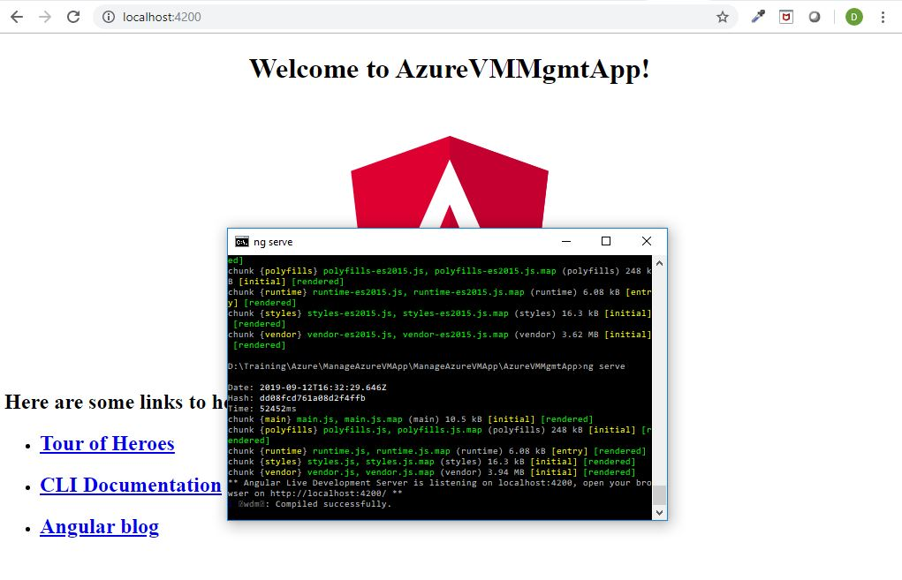

**Step5:** For easy integration with the MVC application move the essential files and folders to root folder of the MVC application with necessary configuration changes.

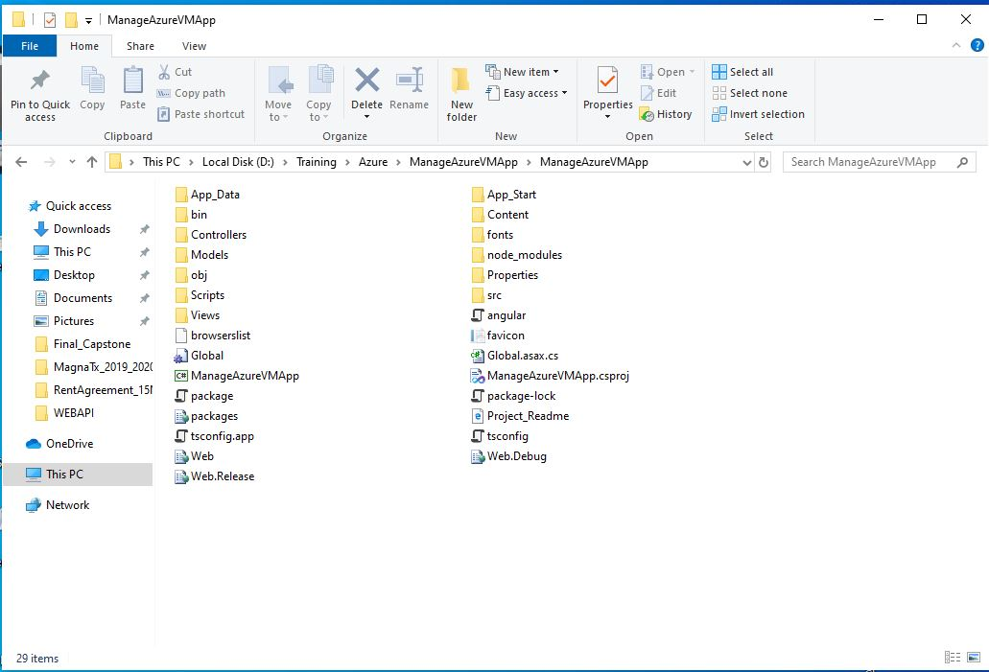

Step6 : Develop the angular application for creating the new VM through Web API call.

1. Implement an angular service **VmrequestService** which invoke the Web Api at <https://fcvmapi.azurewebsites.net/api/ManageVM> . Then import and declare in providers section in app module.
2. Implement an angular component **NewvmComponent** in folder **newvm** which accepts parameter values for new Azure VM and call the service method **VmrequestService.deployNewVM.** Form is implemented using angular form builder and the **VmrequestService** instance is available through dependency injection.
3. Import and declare **NewvmComponent** as bootstrap component in app module.

Step7: Build the angular app using **ng build** command in project folder.

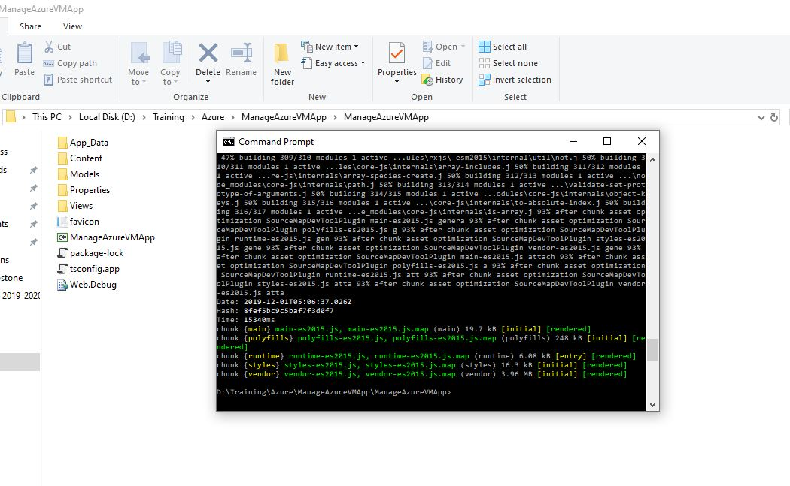

Step8: Open file **View\Home\Index.cshtml** and add the angular generated js files as shown below.

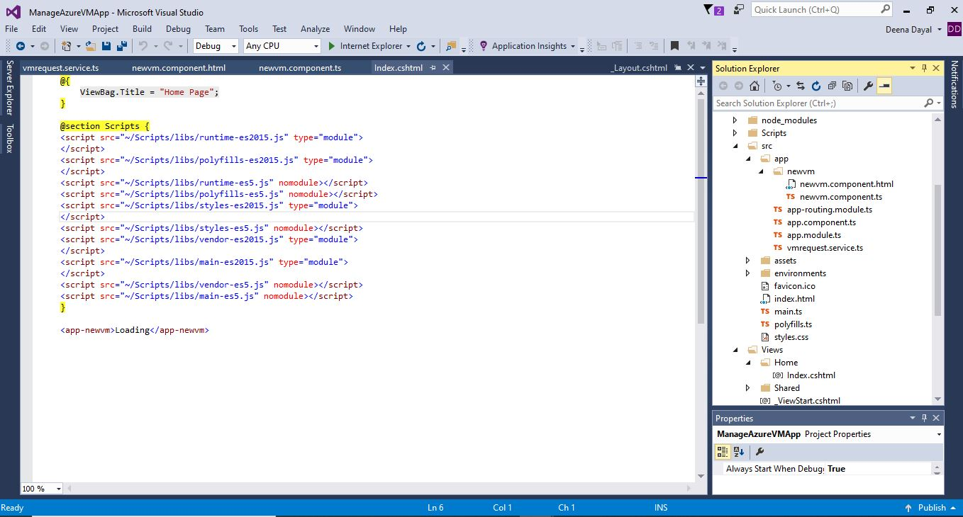

Step9: Build and verify the ASP.Net MVC application

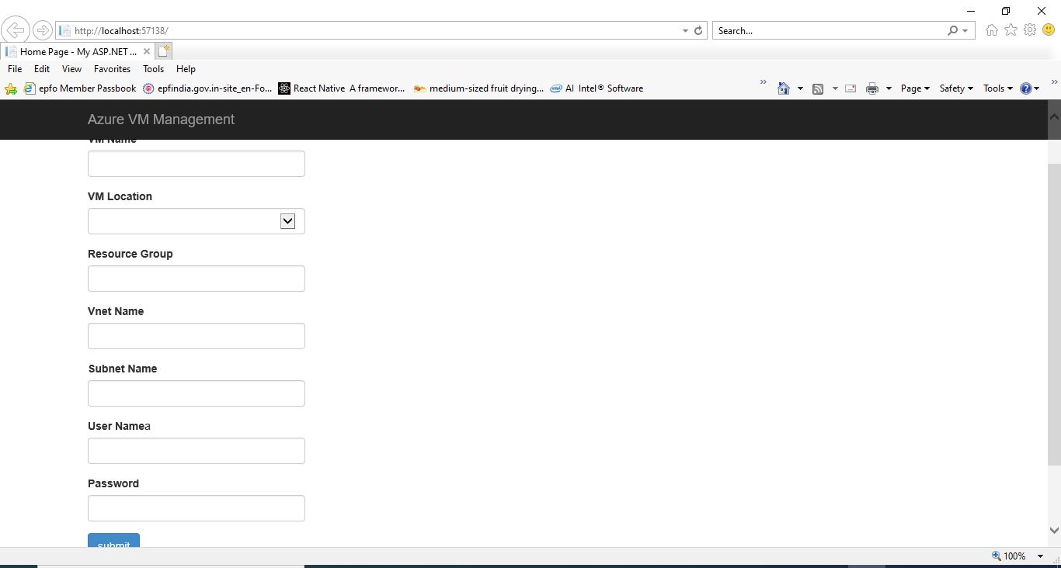

Step10: For handling the bearer token while accessing the Web API we use MSAL-Angular (Microsoft Authentication Library). Install the module using the command “**npm install @azure/msal-angular –save**” in command line as shown below. Once installed integrate the MSAL code in to the angular application.

